RECOMMENDER ENGINE

CHAPTER 1
ASSOCIATION RULE
APRIORI ALGORTIHM:
- Frequent Itemset Generation: Apriori algorithm efficiently identifies frequent itemsets in a dataset, which are sets of items that frequently co-occur together.
- Support Threshold: It employs a support threshold to determine the minimum occurrence frequency required for an itemset to be considered frequent, aiding in filtering out less significant itemsets.
- Candidate Generation: Apriori uses a "join" and "prune" strategy to generate candidate itemsets, reducing the search space by avoiding the generation of infrequent itemsets.
- Association Rule Mining: Based on the frequent itemsets found, Apriori then derives association rules, which express relationships between different items in the dataset, facilitating insights into customer behavior, market basket analysis, and more.
DATA:
- Order_item_history table is taken for mining the rules.
- Columns that we use from this table was “order_id, item_id, item_name”.
- “Order_item_id” is the primary key of this table.
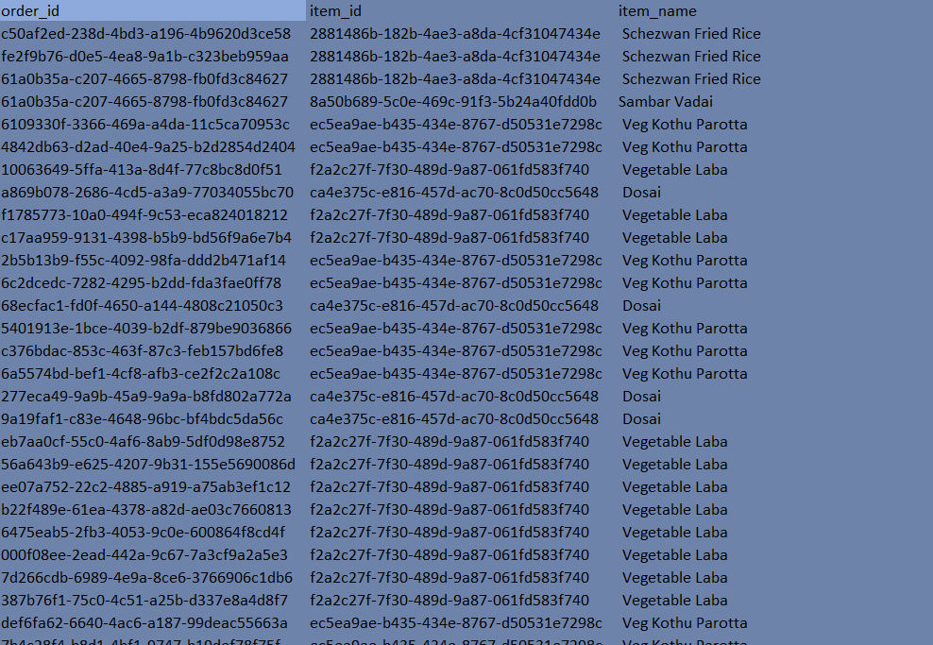
- Insights on Magilhub Data.
Order_id -> 2979 unique values
Item_id -> 208 unique values
Item_name -> 189 unique values

- Grouping Data (order_id -> item_name).

Sample Data:
order_id | item_name
1 | Apple
1 | Banana
2 | Banana
2 | Orange
2 | Apple
3 | Banana
3 | Orange
After Grouping:
order_id | item_names
1 | ['Apple', 'Banana']
2 | ['Banana', 'Orange', 'Apple']
3 | ['Banana', 'Orange']

Association rule from Sample Data:
- {Apple} => {Banana} (Support = 1/3, Confidence = 1)
- {Banana} => {Apple} (Support = 1/3, Confidence = 1)
- {Orange} => {Banana} (Support = 2/3, Confidence = 1)
- {Banana} => {Orange} (Support = 2/3, Confidence = 1)
- {Apple} => {Banana, Orange} (Support = 1/3, Confidence = 1)
- {Banana, Orange} => {Apple} (Support = 1/3, Confidence = 1)

Association Rules (Magil data):
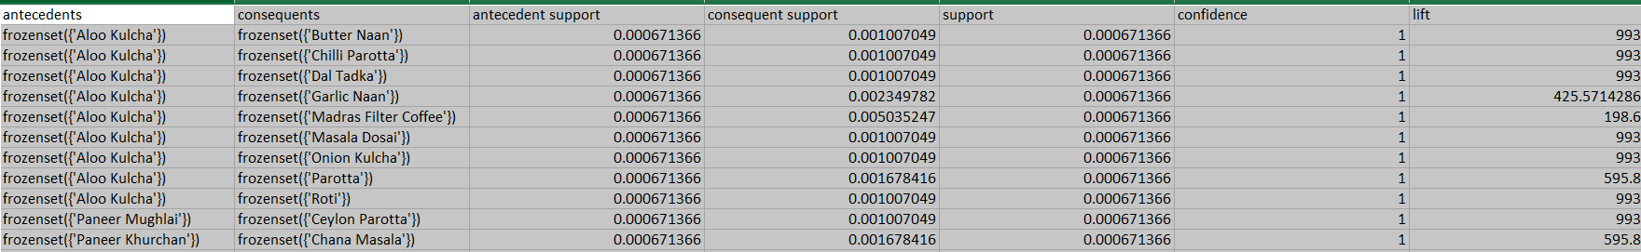
Totally, there were [52189 rows x 10 columns]. So, potentially we have 52189 association rules for 189 unique items.
Testing Results:
